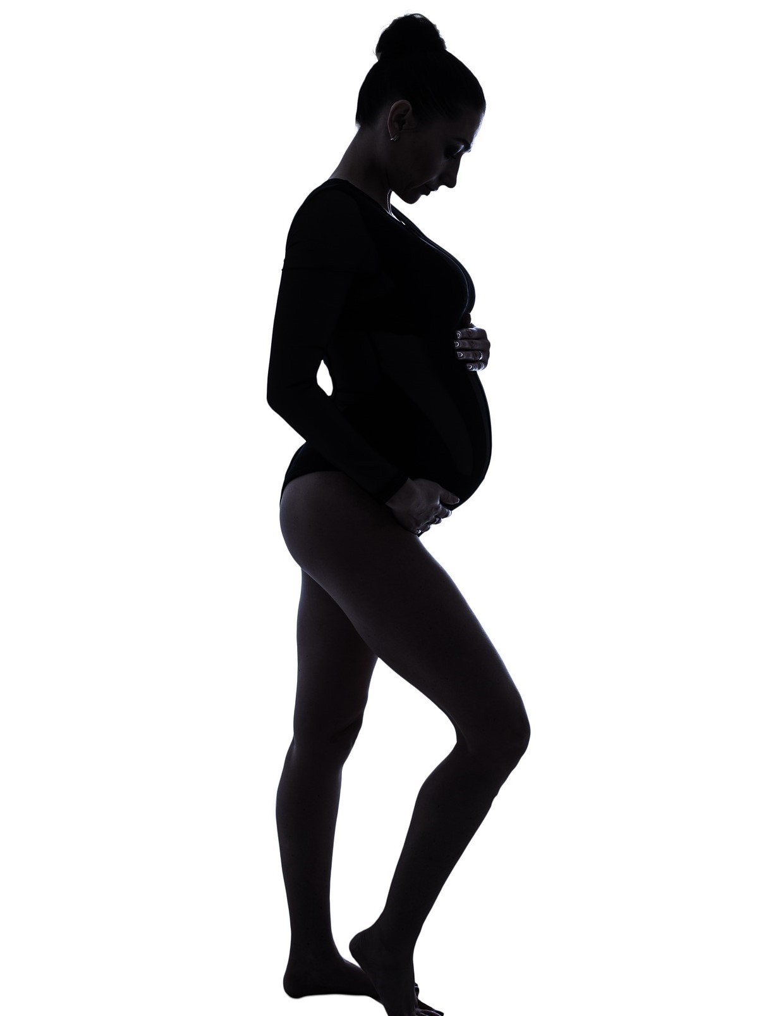

Pregnancy Accommodation Request Form
Updated February 2022

Your request for a pregnancy accommodation, and information submitted in support of or related to the request, will be kept private, except that it will be shared with those University officials who are involved in evaluating and/or implementing the request.
Any questions regarding the reasonable accommodation policy or process should be directed to Elizabeth M. Garcia, Executive Director for the Office of Equity and Diversity, Institute of Molecular Biology and Medicine, Suite 315, (570) 941-6645, elizabeth.garcia2@scranton.edu.
Please review the policy at https://www.scranton.edu/equity-diversity/docs/employee-pregnancy-policy.pdf
To be Completed by Employee/Applicant:.
Name:____________________________________________ Date:_____________R#________________
Email:____________________________________________ Phone #:____________________________
Department:_______________________________________ Position:____________________________
Supervisor:________________________________________ Supervisor’s ph.#______________________
- Please describe the accommodation(s) or modification(s) you are requesting, including the start and end date:

- Please describe any physical limitations, risks and/or description of the difficulties related to the job that require the accommodations:

- List any other accommodation that would eliminate the limitations, risks and/or difficulties:

I understand that the specific accommodations requested may not be granted, but that the University will attempt to provide reasonable accommodation that does not create and undue hardship on the University.
Signature: Date:
Date Received by OED:

